

**October 2023**

[***www.piccadillyskiclub.com***](http://www.piccadillyskiclub.com/)

***Est 1972***

**Next Meetings:**

**Thurs, Oct 5, 7pm**

**Thurs, Oct 19, 7pm**

**Miller’s Ale House | 455 Butterfield Rd |Lombard**

Email: [ComeSkiWithUs@piccadillyskiclub.com](mailto:ComeSkiWithUs@piccadillyskiclub.com)

***President’s Message:***

Things are really humming in PSC.  The Fall Foliage cruisers are back, full of great stories about the east coast, and our fall season is packed to the brim with fun activities.   We have candlelight bowling at the Tivoli, and another great play downtown from City Lit Theatre, the same folks who brought us “The Mark of Kane.”  Some of our most favorite clubs events are this month as well: Our Open House night, annual Bike Ride & Chili Cookout, Backyard Oktoberfest party, Bear’s game at Suburbanite Bowl, and the Warren Miller movie premier at the Tivoli.  All this even as we prepare for our season of big trips.

Please see our website for details, or better yet, come to our special club meeting on October 5th - SKI BEE/Membership Open House.  We hope to see you there.  BTW, don’t forget to dress in Halloween costumes for our October 19th meeting & Halloween trivia night.

Hope to see you at these events, and of course, go Bearzzz!!!

---Paul F---

***---Paul Fuka, PSC President---***

. Cheers! Terry

***Share Piccadilly with your friends and keep our club growing strong!*** Grab some more business cards for the wallet or purse at the next meeting. Carry them with you, and hand them out to prospective members…. An easy way to invite a friend to check us out!

***Where in the World is Piccadilly?***

Let’s find out! As you travel to near and far places, bring along PSC logo gear and take a photo of you with that swag (neck wallet, jacket, facemask, business card, pin, bandana, shirt, coat, vest, backpack, koozie, etc.) Be sure to show the PSC logo in the photo, and you of course, along with your travel location as your backdrop, and email it to me, Dawn, at [rockaroche3@gmail.com](mailto:rockaroche3@gmail.com) subject line: Where in the world… It does NOT have to be across the world, but it would be fun if it was, and hopefully somewhere identifiable. Or, we’ll have fun guessing.

*Right: Piccadilly Business Card pedaled the Cal Sag trail with Kevin’s Thursday bike gang!*

*Left: PSC Coozie ‘floated’ in Tellico Lake, TN with Chris & Cathie Dunn, and Mike & Dawn R and friends.*

*Right: Piccadilly 50th Patch relaxed at a Cabo San Lucas resort with*

*Grant L and gal pal, Enidth.*

*Left: Piccadilly Business Card declared a ‘beach day’ at Frankfort Beach, Frankfort, MI with Johnny O.*

*Right: Piccadilly Business Card explored Mike’s Namesake Harbor – Roche Harbor – in the San Juan Islands along with Walt & Cheri T.*

*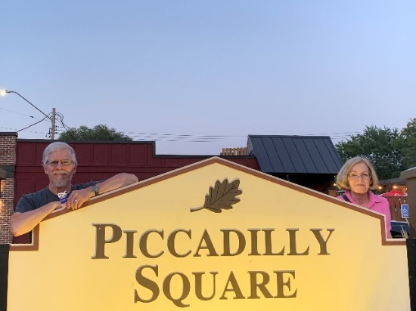Right: Piccadilly Business Card visited family at Piccadilly Square in Mahtomedi, MN along with Eileen & Duane A.*

*Left: Piccadilly Business Card found some ‘bathroom humor’ at Church Street Brewery, Itasca, along with Larry H*

*Right: Piccadilly Flags swarm Ted R., and his car in Bar Harbor, ME. Let the adventures begin!!!*

*Left: Piccadilly 50th Patch strikes a pose with Schaumburg Boomers Mascot “Coop” at a playoff game, and Larry H.*

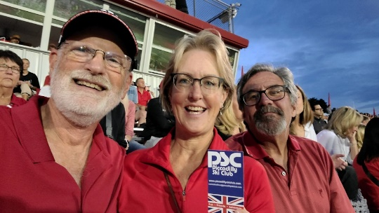*Left: PSC Business Card cheered on the Hinsdale Red Devil’s high school homecoming football team along with Grant L, Dawn R., and Mike R.*

*Right: Piccadilly Business Card wants you to guess this one…Where are Allison and Vicki?*

**Take Piccadilly**

**on *your* next adventure!**

***Social Media***

Ahhh yes, we all remember a simpler time without cell phones glued to our palm. But they’re here to stay and Social Media is a part of it all. Did you know Piccadilly is on Facebook, MeetUp and Instagram? Why? We are working hard to promote our club to attract and keep new members. Using Social Media is a way of reaching and introducing our club to a new demographic. This will help ensure the vitality of Piccadilly and keep it growing into the future!

**How can you help?**

* **You can “Like” our Facebook posts, and share them.**
* **You can “Follow” us on Instagram and “Like” our posts.**
* **You can sign up for MeetUp and use it to RSVP for events and meetings.**

**Create Your MeetUp Account -** People need to RSVP to events on MeetUp and so it's very important to be a PSC MeetUp member.  Your information is kept private, just post your facial picture so we can associate the member with an event. We use this convenient tool to communicate with you for our events, like where to gather, last-minute event changes, or weather alerts. Please help our Event Hosts reach you for notification and help them know who to look for so we can sit together! We also use MeetUp to give a headcount to Miller’s, so they can assign proper staffing, and finally, we can attract more MeetUp members which translates to new Piccadilly memberships to keep our club thriving. [www.MeetUp.com](http://www.meetup.com) As you can see, there are many good reasons to create your account today! If you need help, see one of your board members. - ***Thanks, Pam***

**Follow us on Instagram -** Please go to your Instagram account (if you have one), search for Piccadilly Ski Club and “follow” us. That’s all you have to do. Then PSC will follow you back. It’s another way of promoting our club, attracting new members and keeping our club thriving.

**"Like us on Facebook"** Help Piccadilly reach more

potential members!

**TRAVEL INSURANCE**

Tip: Explore the “Cancel for any reason” version of trip insurance, to see if that’s the best fit for you, but be advised you will need to purchase that version very shortly after your first trip payment.Here are helpful links from the CMSC website for your convenience. (PSC does **not** endorse any insurance carrier)

<http://www.csatravelpro.com/WINTERSPORTTOUR>

<http://www.travelprotectors.com>

<https://www.allianztravelinsurance.com>

***Social at-a-Glance* (Details below in the newsletter)**

*Do you have suggestions for future events, or want to host one? Contact* *John at* [*jfosullivan56@att.net*](mailto:jfosullivan56@att.net)

* **Thurs, 10/5** - 7pm - General Mtg, RSVP on MeetUp. SKI BEE/MEMBERSHIP NIGHT
* **Fri, 10/6 -** 6pm - Candlelight Bowl at the Tivoli. Must RSVP & Pre-Pay direct to Linda C.
* **Sat, 10/7 -** 5:30pm/7:30pm – Dinner & a play in Chicago *‘The Innocence of Seduction’*
* **Sat 10/14 -** 1:30pm - Kevin’s Bike Ride & Chili Bonfire. Sign up directly with Kevin
* **Thurs, 10/19** - 7pm - General Mtg, HALLOWEEN Theme. RSVP on MeetUp for Headcount
* **Sun, 10/22** - Noon Kickoff- Bears vs. Raiders at Suburbanite Bowl. Appreciation Event
* **Tues, 10/24** - 7:30pm – Warren Miller Movie in Chicago
* **Wed, 10/25**  - 7:30pm – Warren Miller Movie at Downers Grove Tivoli. Stop by the PSC Booth. Wear PSC clothing to show your spirit!
* **Fri, 10/27**  - 6pm - Vicki’s Wine Tasting Event. Mark your calendars, details to come
* **Thur 11/2** - 7pm - General Mtg, RSVP on MeetUp for Headcount
* **Wed, 11/8** – 7pm – 8:45pm – Feed My Starving Children, Sign Up on MeetUp
* **Thur, 11/9 –** 10am – 10:30am Virtual Yoga pop up event
* **Thur 11/9** – 6pm-8pm – King Keyser Shop & Save Event
* **Thur 11/16** - 7pm - General Mtg, RSVP on MeetUp for Headcount
* **Sat 11/18 – 12 Noon/2pm**  - Hike and Brew… another Piccadilly “Twofer”
* **Plus:** Harry’s Pub Crawl by Train, coming to a station near you. Date and deets to come

***PSC Favorite Ski Stories & Pics***

*Can you name all these samurai dudes? Answers later in this publication.*

***Trip Payments Due this month\****

**[](https://www.pexels.com/search/money/)10/5/23**

**10/19/23**

Panorama $250

Brule $100

Snowbird $325

Mystery Trip $50

Banff $300

Beaver Creek $300

***\**** *Please turn in your checks promptly, during meetings at Miller’s, or mail to P.O. Box 207, Downers Grove, IL 60515. All checks are made out to Piccadilly Ski Club; please note in the memo section which trip to apply payment.*

*Thank you.****-Julian & Jackie***

***Trip Updates***

Punta Cana has just gone to waitlist status, but there are still openings on all our ski trips. Plus, the early bird pricing is still available for Midwest destinations, so don’t delay, sign up today!

***Trips*** ***at-a-Glance***

|  |  |  |  |  |
| --- | --- | --- | --- | --- |
| **Trip Name** | **Trip Dates** | **Pricing\*\*** | **Status** | **Contact Info** |
| **Punta Cana** | **12/2 – 12/8/23** | **$1625** | **Waitlist** | **Sue Akk**  [Akk331@sbcglobal.com](mailto:Akk331@sbcglobal.com) |
| **Panorama** | **1/11 - 1/16/24** | **$1500** | **Open** | **Paul Fuka**  [ebcdicffff@att.net](mailto:ebcdicffff@att.net) |
| **Mystery** | **1/20/24** | **$155\*\*** | **Open** | **Cheryl Skurkis**  bcskiies@aol.com |
| **Ski Brule** | **2/2 - 2/4/24** | **$520\*\*** | **Open** | **Donna Prenta**  donnamprenta@gmail.com |
| **Beaver Creek** | **2/10 - 2/17/24** | **$1670 + EPIC Day Pass** | **Open** | **Sandi Siakel**  [ssssiakel@gmail.com](mailto:ssssiakel@gmail.com) |
| **CMSC Banff** | **2/24 - 3/2/24** | **$2335** | **Open** | **Terry Turlek**  turlekt@gmail.com |
| **Snowbird** | **3/16 - 3/23/24** | **$2400** | **Open** | **Mike Roche**  [mikeroche417@gmail.com](mailto:mikeroche417@gmail.com) |
| **\*\*Early Bird Pricing in effect until end of 12/7 meeting for Midwest & 1-Day Trips.**  ***Note: Early Bird Pricing for out west trips has expired.*** | | | | |
|  |  |  |  |  |

***Featured Trips***

**PANORAMA SKI RESORT**

**Hello skiers!  The Panorama trip is a gem you shouldn’t miss,**

**with all the amenities of a luxury trip on a budget price!**

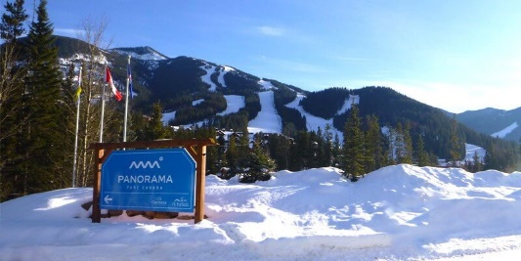Capsule Summary:  Panorama is extremely reasonable at $1500.00 including lift ticket, ski-in/ski-out of condos with kitchens(!), and 3000 acres of low-altitude breathtakingly beautiful skiing for all ability levels.

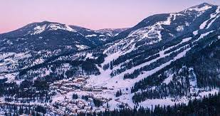Skiing details:

* January 11th – January 16th
* Did we mention breathtakingly beautiful scenery?
* Summit is only 8,000 feet
* Evenly split:  15% Beginner/ 35% Intermediate/ 20% Advanced/ 30% Expert
* 141 total runs
* 4265 feet vertical drop
* 2,975 skiable acres, with 100 acres of night skiing
* Longest run is 4 miles top to bottom
* 1 gondola, 10 lifts
* AND there is a back bowl – with lots of challenging terrain

We stay at the Panorama Springs Lodge

* Ski-in / Ski-out(!)
* Condos with Kitchens
* Gas fireplaces
* 2 heated outdoor pools

**Dates: 1/11/24 - 1/16/24**

**Cost: $ 1,500**

**Trip Leader: Paul Fuka**

**Contact info:** [ebcdicffff@att.net](mailto:ebcdicffff@att.net) | **Cell: 847-542-2566**

**SNOWBIRD, UT**

**In the Little Cottonwood Canyon**

The Greatest Snow on Earth! What’s not to like?

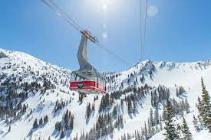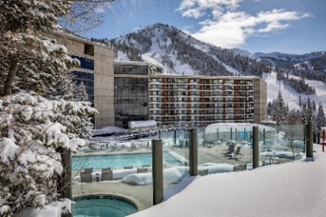Nestled in Little Cottonwood Canyon in Utah’s Wasatch Mountain Range (and located an unbelievably short 38-minute bus ride from the airport), Snowbird is internationally known as being the home of the *Greatest Snow on Earth* and has some of the best lift-served terrain in the nation. They offer a wide variety of runs, 28% Beginner/38% Intermediate/35% Advanced-Expert, so there is something for everyone. The Top of the Bird is at 11,000 feet and they are known for having plenty of snow in mid-March, especially with an average of 500” (that’s right 500”) per year. Snowbird offers over 2,500 acres of legendary terrain, a 3,240’ vertical drop, and a 3.5-mile trail from top to bottom.

Piccadilly is staying at the Cliff Lodge, with ski-in/ski-out luxury, a heated outdoor pool and hot tubs, and available Spa! Our pricing includes airfare, ground transfers, convenient lodging, Snowbird-only lift tickets*, one breakfast, 10% discounts on Spa Club access, a mountain tour, a 20% discount on rentals, and all the fun that goes with being on a Piccadilly trip. Our club hasn’t been to the Bird since 2002, so look out Little Cottonwood Canyon, here we come!

Lodging: Cliff Lodge (@Snowbird), Canyon View (2 Q beds, minifridge, coffee maker), 2 per room

Flight info: American Airlines direct into SLC (did we mention the short bus ride?)

**Dates: 3/16/2024 – 3/23/2024**

**Cost: $ 2,400**

**Trip Leader: Mike Roche**

**Contact info:** [**mikeroche417@gmail.com**](mailto:mikeroche417@gmail.com) **| Cell: 630-465-3194**

*\* A 5-day Snowbird-only lift pass (plus a 6th day free) is included in this pricing. The $ surcharge for the Snowbird-Alta interconnect lift ticket is TBD. For those of you buying your own IKON Pass, talk to your Trip Leader for more details.*

***Social Details***

**Next 2 Meetings:**

**Oct 5 & Oct 19**

**455 Butterfield Road, Lombard**

**Across from Yorktown**

**Piccadilly SKI BEE (Membership Open House) Thurs, 10/5, 7pm**

**\* Come for the RAFFLE - Over 30 prizes!!!**

**\* Come to show your PSC Spirit**

**\* Come for a Great Time**

**\* It’s not just a meeting…. IT’S A PARTY**

Our SKI BEE tradition continues this year. Help celebrate and show your PSC spirit at this special meeting by wearing your favorite PSC SWAG. Bring a non-member friend too. That is how we grow the club. Pick out a crazy skiing T-shirt or your PSC Polo or maybe a colorful shirt from your favorite ski area. Show our new members that we are PSC, and we love to ski, board, and have fun.

We have AWESOME prizes for the raffle including donations from: *Viking Ski Shop * ERIKS Ski & Bike *Sunshine Village (BANFF) *Whitefish Mt. Lodge * Beaver Creek* Ski Brule *Telluride *Breckenridge * Donna Prenta *Sandi Siakel * PSC SWAG * PSC $ki Buck$.

Barry & Cheryl are dressed and ready for the ‘BEE’

This year we are going to have a **“Pick-a-Prize”** raffle for a few special items. You can put ½ of the ticket in the General Raffle box **OR** drop your ticket in the box just for one of the Special Prizes. (Don’t forget to keep your ½ of the ticket). Tickets are still $1 each and 6 for $5.

**GOGGLES BOOT BAG TRIP for 2 GENERAL RAFFLE 30+ PRIZES**

**DON’T MISS ALL THE BUZZ 🡪 🡪 JUST BEE THERE!!!**

REMINDER: SKI BEE is also the last chance to *renew* your membership for only $10. After that, all memberships are $30. Remember, you must be a current member of PSC 2023-2024 to go on our awesome trips. Bring a friends, checkbooks and/or cash for Raffle Tickets and membership renewal. We are off to a great start, but our goal is to top last year. Forms & other member info is online: [www.piccadillyskiclub.com/membership](http://www.piccadillyskiclub.com/membership)

***- Larry Himmelblau, PSC Membership Chair / Historian***

**Candlelight Bowl at the Tivoli – Fri. 10/6, 6pm**

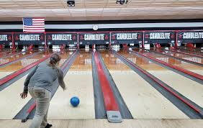

**There’s still time! This event is open for sign-ups until Wednesday, October 4th.** Join Piccadillians for an evening of Bowling and Frivolity! For a mere $30 per person, you get Dinner & Bowling. Dinner of Appetizers, Salad and Pizza will be waiting when you arrive at 6pm. Bowling will start at 6:30pm. We’ll set up four-man teams. We can accommodate up to 48 players for two games. There will be a cash bar. Shoes are included in the fee. Reserve your place by contacting Linda Cooper – [cooper.linda@comcast.net](mailto:cooper.linda@comcast.net). Payments can be made through Zelle. Note: Also sign up on meetup for headcount and/or waitlist. Hope you can join us.

**Tivoli Bowl, 938 Warren Ave Suite A, Downers Grove.**

***‘The Innocence of Seduction’*, Chicago’s City Lit Theater, Sat., 10/7,**

**5:30pm Dinner/7:30pm Play**

Join us to see the second play in Mark Pracht's “Four-Color Trilogy” of plays set during the early years of the comic book industry. If you saw the first play of the trilogy, ”The Mark of Kane”, you're in for another treat! If you didn't see “The Mark of Kane”, this exciting next addition stands alone and will prove to be a fascinating look into the 1950s Congressional investigation into the supposed link between comic books and juvenile delinquency; along with the effect of the investigation on the careers of three persons: William Gaines, the originator of the horror genre of comic books; Matt Baker, a Black closeted gay artist of romance comics; and Janice Valleau, creator of a pioneering comics feature starring a woman detective. Directed by Mark Pracht. City Lit Theater is located at 1020 West Bryn Mawr Avenue, on the second floor of the Edgewater Presbyterian Church at the corner of Bryn Mawr and Kenmore, right around the corner from where Lake Shore Drive starts at Hollywood and Sheridan.



Tickets for “The Innocence of Seduction” are $34 Adult /$29 Senior at tickets <https://www.citylit.org> We'll meet for dinner beforehand, 5:30 p.m., at the fun Edgewater Mexican Cafe, 1055 West Bryn Mawr. For playgoers, 15% off your check, and you can leave your car in the lot (free parking!) **Sign-up on Meetup** and also confirm on Meetup if you will be joining us for dinner so that we can include you on the reservation. For those not dining with us, parking is available for $8 at St. Andrew's Greek Orthodox Church. Prebooking is required, and you can pay for parking when you purchase your tickets for the play online. Or you can try your luck with on-street parking. Join us for an after-show drink at La Pharmacie, 5545 N. Sheridan Road (corner of Bryn Mawr and Sheridan inside the pink building) – Contact me with any questions, David Valenta dvalenta@ameritech.net

**8th Annual Fall Bike Ride/Chili/Bonfire, Sat, 10/14, 1:30pm**

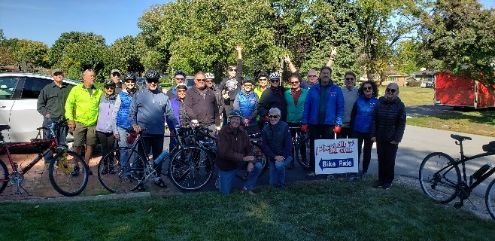**WHEN** – Meet about 1:30pm @ Kevin Conlon’s house – RSVP for address.

**RIDE** – about 2pm. Total ride is about 12 miles (10 miles around Argonne/Waterfall Glen, 1 mile to/from Kevin’s)

**EAT** – about 4:30pm – Kevin will provide Chili with all the fixings (Cheese, Onion, Sour Cream, Crackers etc.).  Yes, there will be chili dogs too!

**BONFIRE** – at sunset (about 6:00pm)

**HOW TO SIGN UP** – You can sign up in person at a Piccadilly Ski Club meeting or you can RSVP by September 30th to 708-906-9517 or [Kconz1@aol.com](mailto:Kconz1@aol.com). First come/First served. Space will be limited to 40 people because of food. Priority is given to actual members of Piccadilly Ski Club. Sign-ups are NOT allowed thru Meetup.

Bring your own beverages and lawn chairs. You can bring a dish to pass if you’d like but it’s not required. If you don’t ride, you are still welcome to come for Chili and Bonfire, if space is available, but you will have to listen to everyone’s “tails of the ride”.

**Suburbanite Bowl Appreciation Event, Sun, 10/22, 12noon kickoff**

**Bears vs. Las Vegas Raiders**

Come on out and root for the Bears! This is our way of showing appreciation for our longtime friends at Suburbanite Bowl in Westmont who have allowed us to park in their lot during our Midwest and One Day trips.

Food can be ordered from across the street at Zazzo’s Pizza. They have done a good job of delivering food orders across the street to us in the bar. Let’s all gather to say thank you!

**Suburbanite Bowl, 201 W. Ogden,**

**Westmont. (630) 968-2200**

**The 74th Warren Miller “ALL TIME”  Film Premiere, 10/25 , 7:30PM**

Kick off your ski season with the ever-popular Warren Miller movies that showcase extreme skiing and boarding at their best**. Buy Your Tickets Online Now!** <https://www.eventbrite.com/e/downers-grove-il-warren-millers-all-time-730pm-tickets-696108548407?aff=oddtdtcreator>

Warren Miller Entertainment is getting ready to celebrate 75 years of Warren Miller films and this anniversary is too big to fit in a single film, or even a single year, so we’re building a two-year celebration of Warren’s legacy.

Get ready to go deep into the stuff of which snowy dreams are made. Celebrate the birth of ski towns like Sun Valley and Aspen, icons and innovators like the original hotdoggers, and the most outlandish locations ever skied. Then, catch new footage featuring Maine’s finest athlete of today, Donny Pelletier, and meet the next generation of Warren Miller daredevils. Through it all, Jonny Moseley and special guests will share their own stories to bring us to this moment. It’s all going down this fall as we kick off our two-year party for 75 seasons on snow.

PSC will have a table in the lobby for the Wednesday, 10/25/23 Tivoli showing in Downers Grove. So stop by early to say hello! There will be prizes and giveaways throughout the evening. Wear your PSC gear and stop by our table to show your support. Here are the two Chicagoland showings of ‘*ALL TIME’.*

* **Chicago - History Museum, Tues, 10/24, 7:30pm**
* **Downers Grove - Tivoli Theatre, Wed., 10/25, 7:30pm**

**PSC Gives Back! Feed My Starving Children – Wed., 11/8, 7pm - 8:45pm**

**“Chicken * Veggies * Soy * Rice”**

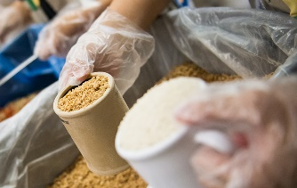We’re back, with this popular holiday giving opportunity to feed underserved children in the U.S. and around the world. Feed My Starving Children was founded as a nonprofit during a humanitarian visit to Honduras and now ships much needed food packets to over 90 countries. You’ll get to make the meal packets (nutritional food packets containing rice, soy, veggies, chicken flavoring, vitamins and minerals) to be shipped out immediately! The results are dramatic for these children. 20 spots have been reserved for our PSC family. Please sign up via MeetUp. Let’s all wear our PSC shirts, and meet prior to grab a nibble together. Restaurant location TBD. Feed My Starving Children, 555 Exchange Court, Aurora, IL 60504 **Event Hosts: Mike & Dawn Roche**.

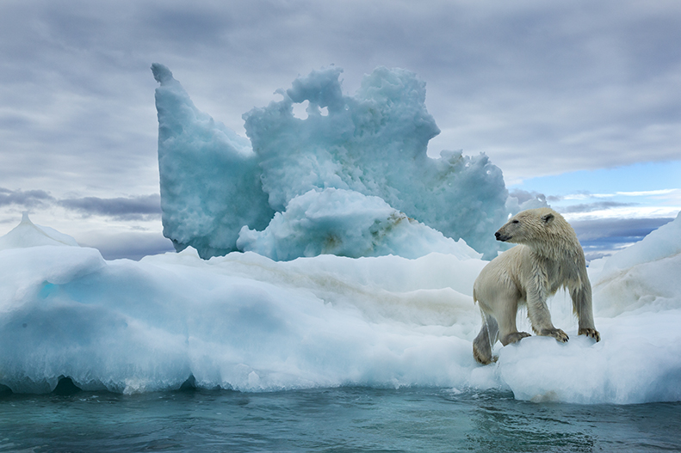**Pop Up Virtual Class, Thurs, 11/9, 10-10:30am**

**A Yogic Approach to healthy skiing**

# Breathe Awareness, Joint Movement & Lunges

# Led by Donna Prenta, RYT500

**Join Zoom Meeting 5 minutes early to work out any tech issues.**

[**https://us06web.zoom.us/j/82742739124?pwd=bUdpVEo3WDJnQ3U4UUNoaWVmbGtsZz09**](https://us06web.zoom.us/j/82742739124?pwd=bUdpVEo3WDJnQ3U4UUNoaWVmbGtsZz09)

**Meeting ID: 827 4273 9124 | Passcode: 831564**

* Chair or Yoga Mat needed. | Questions? email: [donnamprenta@gmail.com](mailto:donnamprenta@gmail.com)

**King Keyser Night – Shop & Save 10% – Thurs 11/9, 6pm-8pm**

**41 S. Washington Street in downtown Hinsdale**

Does your ski gear still fit? Is it worn out? Has it been a while since you upgraded your outfit (Mike?) If yes, then stop into King Keyser Ski Shop to check out all the new gear and great deals for the 2023-2024 season.

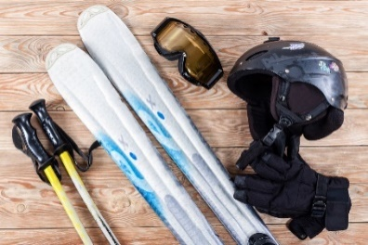

**Piccadilly Members receive 10% off this night**

**so be sure to have your Membership Card handy.**

Parking is free after 6pm and King Keyser will be open for PSC until 8:00 pm. Feel free to arrive early if you would like extra time to shop.  PSC-provided lite refreshments included.

***- Skimeister Donna***

 **“Twofer” Hike and Brew! I & M Canal Hike + Imperial Oaks Brewery, Sat.11/18, 12noon Hike /2pm Happy Hour**

The newest thing with Piccadilly is the “Twofer”. Come join us for a fall hike – witness the changing of the leaves and experience the I & M canal trail. If you do the whole trail, your hike is @ 2 hours long, hiking @ 4 miles. Anyone concerned about the length can cut it short and head back along the same trail - you can customize the hike to your own comfort zone. Imperial Oaks Brewery (Willow Springs) can be seen from the trail head parking lot, so it’s all right there. Join us for one event or both! Take in the brisk air, get in a little exercise, and get a cold one and some great company as your reward at the end of the trail***.* Sign up on MeetUp so we know who to wait for. Plus, please indicate: hike only, hike & brew, or brew only in the comments.** ***See you on the Trail! - John O***



***CMSC CORNER***

**CMSC Event Schedule**

\***CMSC General Meetings** - Typically held on 2nd Tuesday of each month at Sawa’s Old Warsaw, 9200 W. Cermak Rd., Broadview, IL

**\*ABSF FUNDRAISER STILL GOING -** Deadline for ABSF Fundraiser raffle for the Mougal Monster chair lift seat from Cascade Mountain has been extended to October 15. Tickets are $10 each and can be purschased online at ABSF.org. Winning ticket will be drawn on 10/15/23 at “Jumptoberfest” at Norge Ski Jump. Free delivery of the chair within 70 miles of Lake Zurich.

**\* Oct 3** - TGR Movie “Legend Has It” – Lincoln Hall, 2424 Lincoln Ave, Chicago (Lincoln and Fullerton). Buy tickets online at [www.tetongravity.com](http://www.tetongravity.com)

**\* Oct 14 – 15** - Norge Ski Jump will be holding their Fall Ski Jump Tournament “Jumptoberfest”. Saturday will be Junior Tournament on small hills and K70 jumping. Gates open at 10:00am. Jumping begins at 11:00am. Sunday will be K70 Big Hill Tournament. Gates open at 11:00am. Jumping begins at 12:00 noon. Admission tickets/buttons are available online at [www.norgeskiclub.org](http://www.norgeskiclub.org) @ $20/Adult, otherwise $25 at the gate. Kids 12 & under are Free. More info available at norgeskiclub.org or contact Guy Larson @ [glarson164@gmail.com](mailto:glarson164@gmail.com)

**\* Oct 24 & 25, 2023** - Warren Miller Movie “All Time” October 24th at Chicago History Museum. October 25th at Tivoli in Downers Grove @ 7:30pm. Tickets go on sale in early September.

**\*Jan 12 – 14, 2024** - Travel and Adventure Show at Donald E. Stevens Convention Center, **Save the Date** More info to follow.

**\*Jan 26 – Feb 7, 2024 -** CMSC Europe – Zermatt Switzerland and Milan Italy. Trip packages starting at $3,997. 35 people are currently signed up. Spots are still available. Info is available on CMSC website at [www.skicmsc.com](http://www.skicmsc.com) or contact Steve Patzer at [scpatzer@hotmail.com](mailto:scpatzer@hotmail.com)

**\*Feb 24 – March 2, 2024** - CMSC Chicago Week – Banff, Canada. See PSC trips.

\***April 7 – April 12, 2024** – CMSC Spring Fling – Mammoth Mountain, CA. Trip packages starting at $1,239/pp + air. Includes 5 nights lodging at Mammoth Mountain Inn, choice of QQ room, K room or 2br/2ba + loft condo lodging options (4/5ppl), 4 day lift ticket (IKON accepted), ground transportation and $100 resort voucher. Optional side trip to June Mountain. Contact Kevin Conlon at [kconz1@aol.com](mailto:kconz1@aol.com) or 708-906-9517 for more info.

**\*Feb 22 – March 1, 2025**- CMSC Chicago Week – Jackson Hole, WY **Save the Date**

**\*The “Real ID” deadline has been further delayed until 5/7/25**.

***For more information on CMSC***

[***https://www.skicmsc.com/***](https://www.skicmsc.com/)

***Social Recaps, Ski Stories & Photo Gallery…***

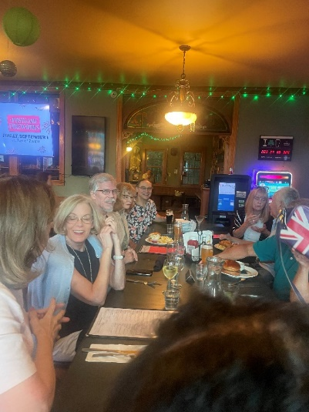**IRISH LEGENDS Dinner for 12 event recap**: The PSC gang turned out for some great food and friendly ambiance. Rich got a Guiness with a Shamrock which worked into his stout libation. The Irish Salmon was a hit and the burgers and Reubens were very well received too. Our table was ready early for us, the stories of Prohibition were plentiful, and everyone learned a little more about Al Capone and his affinity for the place. Dinners for 12 are great and just the right size. Everybody enjoyed their meals and welcoming friends. Thank you, Nancy G., for organizing the event! ***- John O***

**BBQ & Bike Ride recap** - We were blessed with a gorgeous day—sunny and upper 70s—for a 12-plus mile bike ride through St. James Farm and Blackwell Forest. Most of the ride was shaded and treey, with a sunny break at Lincoln Marsh. Thanks to Duane for scoping out a variation on our traditional route and keeping everyone rounded up and accounted for at every turn in the trail😊. All 15 riders returned safely and hungry for a feast of brats and pulled chicken. Ron S tutored Duane in the fine art of a perfectly charred brat. Thanks to all who brought yummy side dishes and desserts. Sharon L’s homemade pineapple upside down cake and Paul K’s salsa were to die for, and of course it wouldn’t be a party without Johnny O’s deviled eggs. Terry T and Vicky S rocked in bags (thanks, Terry for bringing them), while the rest of us enjoyed a leisurely afternoon on the deck with good food and good friends, making yet more treasured PSC memories. Joe S’s adorable buddy, Yoshi, an 8-year-old Japanese Chin, was a perfect guest. Thanks to everyone for coming! ***Eileen and Duane***

**Happy Hour at Bubblehouse Recap -** 37 members and friends crashed the Bubblehouse Brewery for some socializing and libations. They had a great variety of wonderful craft brews and even wine! I really mean, well-crafted beers. Many members of the ski club that would have participated were off on a cruise, hopefully safe and away from hurricane Lee. Bubblehouse was kind enough to allow us to use their special room, but the majority of people decided to hang out in the open space next to the bar where there was plenty of room to stretch out. The wall screen of the Bears game (phew) was available to watch, and some brave souls were even watching closely. People brought snacks and enjoyed grazing off the 12-foot table as they were socializing and kind of watching the Bears. Evan and Carter (behind the bar) served us well, and even brought us a free Oktoberfest toasted pretzel with a tasty mustard sauce to add to the table of goodies. (edit: John’s famous southwestern eggs made an appearance – ever so brief – as many hands were flying to grab them while John was distracted. Yummy!) No wonder we love Bubblehouse! Thanks to everybody who made this a really fun occasion. ***John O***

**JALEO RECAP** - It was a beautiful Sunday evening when 9 Piccadillians ventured down to the River North neighborhood of downtown Chicago for the September Dinner for 12 at Jaleo.  The timing was a little tight but our host - Julian - made it back from the Fall Foliage Cruise in time to greet everyone when they arrived.  Jaleo specializes in Spanish tapas-style fare.  For those who are not familiar with the term tapas: small dishes meant to be shared.  Typically, during happy hour in Spain groups of folks go "bar hopping” - they will go to a bar and order a round of drinks and several tapas, then move on to the next bar and repeat.  To be true to the tapas style of eating, we all agreed to get the Jaleo Classics Chef's Tasting Menu and share everything.  The tasting menu did not disappoint!  We started with stuffed olives and "liquid olives" - you'll have to ask one of us what these are :)  Then came the pan con tomate (bread imported frozen from Barcelona, baked here, then toasted with fresh tomatoes rubbed in the toasted bread), Manchego cheese, and Jamon Iberico (arguably some of the best ham in the world, better than prosciutto - in my opinion).  Next were pastry cones filled with marmalade and goat cheese, then topped with walnut dust.  Next up were endive "boats" filled with goat cheese, mandarin orange sections, almonds, and a roasted garlic dressing.  Still hungry?  You better be because the wonderful food kept coming - Tortilla de patatas classica (Spanish omelette with potatoes and onions), Chicken Croquettes, and thin sliced eggplant soaked in buttermilk then lightly floured and fried, drizzled A group of people sitting at a table
with honey and lemon --- WAY better than potato chips!  This was followed by grilled pork sausage with sauteed white bean, then the main dish came out - two paellas, one with shrimp and squid; and one with chicken, rabbit, artichokes, beans.  But wait - there was more, time for dessert!  Flan with whipped Catalan cream, and brioche ice cream wit dark chocolate cake.  Everyone left the dinner very happy and very full.   For those who didn't want to come downtown for this - you really missed out :) – ***Julian***

**Answer to the Historian Quiz …..Who are these Samurai’s?**

**Back Row, L to R**

1.RICK TAMPIER

2.HARRY MATTSON

3.MIKE ‘POOKIE’ ROCHE

4.TED ROURK

**Front Row, L to R**

5.‘HALF DAY’ MIKE CRYAN

6.BRUCE STANCZAK

7.TOM CANNEY



Happy Halloween – Boo!







 !

"  #$####%



&'# #

( ) 

*

+



 

,##

 -#"##.#.

%. 

 

+#+!/

0" 

Naturalist led Bird banding and hike event Wednesday May, 11

th

, 2022









 !

"  #$####%



&'# #

( ) 

*

+



 

,##

 -#"##.#.

%. 

 

+#+!/

0" 

***PSC 2023 – 2024***

***Board & Appointed Positions***

**President: Paul Fuka**

**Vice President: Sandy Liedtke**

**Secretary: Nancy Goins**

**Treasurer: John Schuurman**

**Trip Chair: Julian Franklin**

**Asst. Trip Chair: Jackie Dudek**

**Membrshp/Historian: Larry Himmelblau**

**Social: John O’Sullivan**

**Publicity: Dawn Roche**

**Webmaster: Pam Rockey**

**Sgt @ Arms/CMSC: Kevin Conlon**

**Ski Meister: Donna Prenta**

**Contact Us: comeskiwithus@piccadillyskiclub.com**

P.O. Box 207, Downers Grove, IL 60515





Email all articles and high-res photos for next newsletter to Dawn Roche.

Deadline: 20th of month prior

**[Rockaroche3@gmail.com](mailto:Rockaroche3@gmail.com)**

Also, email all high-resolution photos to Pam Rockey for our website at [**prockey@sbcglobal.net**](mailto:prockey@sbcglobal.net)

Facebook at: <http://www.facebook.com>

MeetUp at: [http://www.MeetUp.com/Piccadilly-Ski-Social-Club/](http://www.meetup.com/Piccadilly-Ski-Social-Club/)

[**www.piccadillyskiclub.com**](http://www.piccadillyskiclub.com)